Python Project Using Pygame

Game Description:

The game I have chosen to create is called “Simon”, and is based off the original Simon game. There will be four different buttons on the screen, and will be accessed using the arrow keys on the user’s keyboard. The buttons on the screen will light up in a random pattern, and the user has to repeat that pattern correctly. If the user is successful, the pattern will get longer and only end once the user makes a mistake. The goal of the game is for the user to complete the patterns correctly for as long as possible.

Every level (pattern) completed will be counted as 1 point for the user. At the end of the game, the user will be given their score and will be asked to play again or to quit the program.

Extension:

Additionally, if the user has played two or more consecutive games (replays at least once), they will be shown the average of their scores so they can compare and see if they did better.

Achieve:

Through building on Pygame, I will be able to familiarize myself with the Graphical User Interface, and allow me to see how useful it can be in aspects different from the Command Line Interface. Also, I can become better at knowing what types of loops to use, and how, as well as improving on iteration and storing data.

Flowchart: \*(below)\*

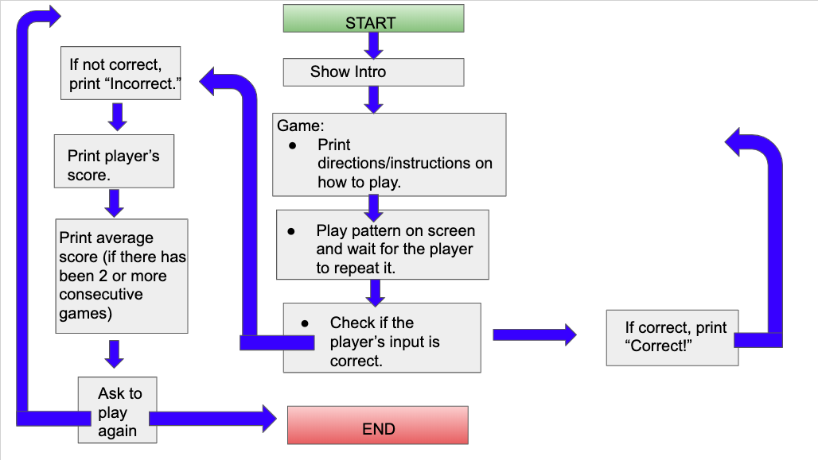

Timeline for Project:

